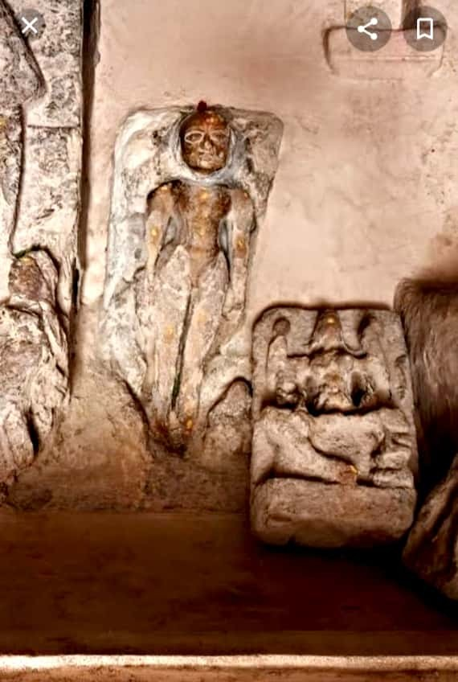

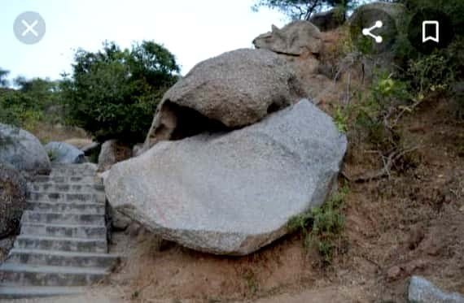

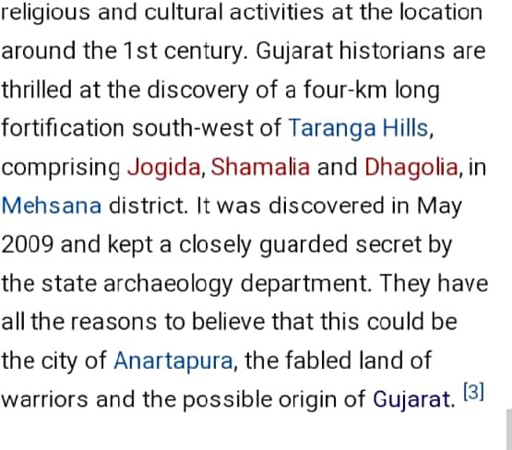

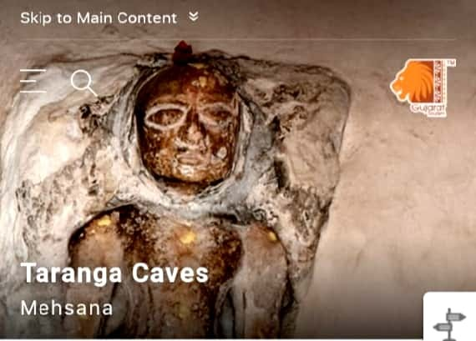

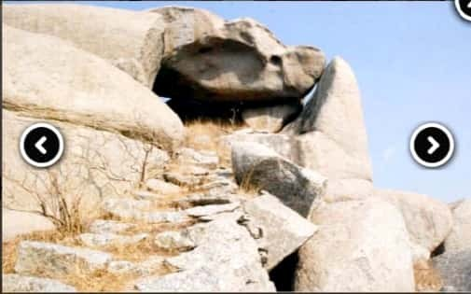




About The Location: Northeast of the main gate of the forl is a cave where the air is extr‹1ordin‹nriIy cool. The cave, locally known as Jogida ni Gufa, was found and used by Buddhist monks thousands of years ago. It has Buddhist sculptures carved in stone that resemble the Bodhi Vriksha or Kalpavruksha and oth»r Buddhist motifs. YOLi also come acr some beautiful Buddhist sculptures on mocinlain on the way to 1he cave. Tarai Hills, 20 km from Vadnagar, on the Ara range, harbours profound connecti‹ with Buddhism. The main idols enshrii
in the Taranmata and Dhcranmata tem« f
are of Buddhist goddess Tara. Brol fl
terracotta images of Buddha, four car› A images of Dhyani Buddha on a st‹ glale, stone and brick h alls inside r‹
shelters, etc. ha›‹e been discovered from
here.

